Researchers have found when instructors use communication tools in online courses, student motivation and participation increase. Each student can view other students’ comments and learn through the exposure to different perspectives.
Students benefit because they can combine new opinions with their own, and develop a solid foundation for learning. Frequent communication and information from the instructor can also enhance student success and retention.
Blackboard Learn offers a wide variety of communication tools allowing you and your students to share information and communicate.
Table of Contents
LEARN THE LINGO 3
KEEPING STUDENTS INFORMED 4
ANNOUNCEMENTS 5
TRY IT 7
Email 8
TRY IT 9
COURSE MESSAGES 10
TRY IT 11
SYLLABUS 12
TRY IT 13
CALENDAR 14
TRY IT 20
CONTACTS 21
TRY IT 22
TASKS 23
TRY IT 26
SPOTLIGHT ON COMMUNICATION 27

LEARN THE LINGO
Announcements
Post course related news, updates, and reminders.
Asynchronous
Method of communication that does NOT require participants to be online at the same time.
Calendar
Provides students with course events and reminders
Contacts
Provides students with profiles of course staff.
Course Messages
Send messages that students access within their courses, and ensure privacy for all course members.
Email
Send email to course members’ external email addresses.
Syllabus
Provides a resource students can consult throughout the course for an outline, objectives, policies, participation, and grading criteria.
Synchronous
Method of communication that requires participants to be online at the same time.
Tasks
Provides students with a list of tasks they must complete.

KEEPING STUDENTS INFORMED
The tools reviewed in this next section are designed to provide your students with the information they need about their course, their assignments, and the course staff. Almost every class will have the need for a Syllabus or Course Outline, but that is only the beginning in relaying important due dates and information.
After completing the activities in this section, you should be able to answer the following questions. Use the space below the question to provide your answer.

- How will you notify students of important dates or reminders?

- How will they know if they’ve completed course milestones?

- Whom should they contact if they have a question?

- How will they contact that person?

Remember: you don’t have to use all the tools in this section, but it is important to identify the tools you feel will work best for you.

ANNOUNCEMENTS
With announcements, you can post timely information critical to course success. On the Announcements page, you can add, edit, and delete announcements. This is an ideal place to post time-sensitive material including:
- Due dates for assignments and projects.
- Changes to your syllabus.
- Corrections/clarifications of materials.
- Exam schedules.
As a default module on the Home Page, announcements are typically one of the first things students see when accessing your course.
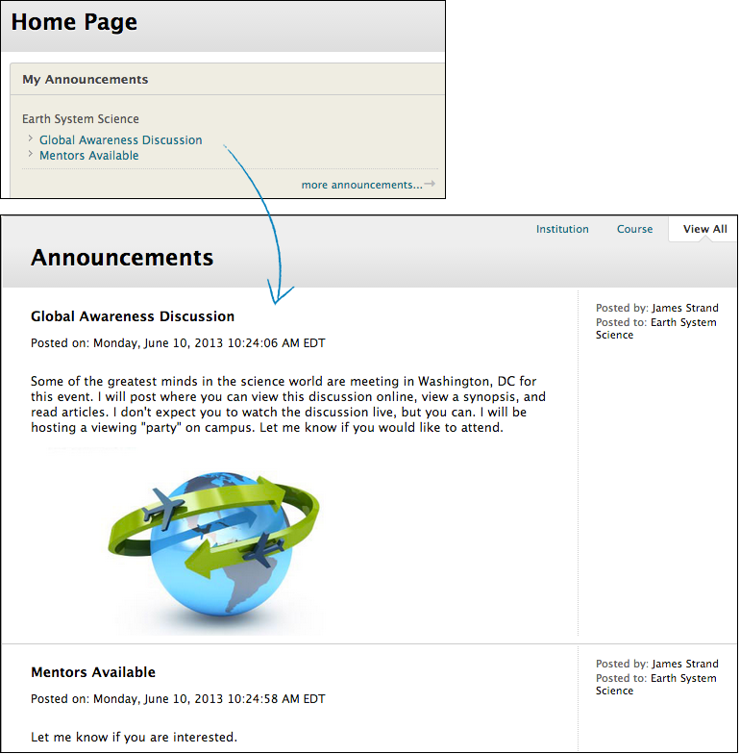

Create an Announcement
Create an Announcement

Display Announcements
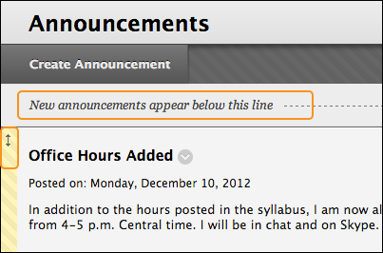
- New Announcements appear directly below the repositionable bar.
  - Move priority announcements above the repositionable bar to pin them to the top of the list.
  - Students do not see the bar.
- Reorder by dragging announcements to new positions.
  - The order displayed is the order presented to students.
  - Students cannot reorder announcements

Edit and Delete Announcements
To edit or delete an announcement, access its contextual menu and click Edit or Delete. The deletion action is final and irreversible.

Access Announcements

TRY IT
For this activity, use your Practice Course.
Use the Announcements tool.
- Create an announcement that appears for the duration of the course.
- Create an announcement to remind students of the upcoming test this week.
- Edit an existing announcement’s title and change an option.
- Create an announcement and select a date a few days in the future for the Date After setting. What happens to this announcement on the main Announcements page when viewing with Edit Mode ON and OFF?
- Reorder the announcements by dragging them to new positions. Place at least one above the repositionable bar.
- Create another new announcement and note where it appears.

Email
In your Blackboard Learn course, you can send email messages to other course members’ external email addresses.
SPECIAL NOTES:
- You cannot send email from a Blackboard Learn course to anyone who is not a member of the course.
- Blackboard Learn does not keep a record of sent emails. You receive a copy of your email in the Inbox of your external email account. Keep a copy of important messages in case you need them at a later date.
- Blackboard Learn does NOT recognize files or email addresses with spaces or special characters, such as #, &, %, and $. In general, use only alphanumeric file names and addresses in Blackboard Learn.
- Do not send email through Blackboard Learn without content in the subject line. Leaving the subject line blank can prevent the message from being delivered.

Watch a Tutorial: How to Send Email
How to Send Email

TRY IT
For this activity, use your Practice Course.
Use the Email tool from the Tool Link.
- Send an email to All Users.
- Send an email to three members of the course.

COURSE MESSAGES
You can send messages to course members using the course messages tool. The course messages tool sends secure electronic messages within the course without relying on external email addresses.
SPECIAL NOTES:
- You organize the messages into custom folders.
- Both incoming and outgoing messages are saved in the course messages tool.
- Course Messages are NOT the same thing as Messages sent using My Blackboard through the Global Navigation.

How to Send Course Messages
How to Send Course Messages

TRY IT
For this activity, use your Practice Course.
Use the Course Messages tool from the Tool Link.
- Send a message to all members.
- Reply to one of the messages you received.
- View the sent message.

SYLLABUS
The syllabus or Course Outline is an important reference students routinely consult throughout a course.
There are two ways to provide this:
- Upload a Syllabus File: attach an existing syllabus file.
- Build a Syllabus File: use the Syllabus Builder to create the file.

Upload a Syllabus File
Uploading an existing file for your syllabus minimizes vertical scrolling because it takes up less space in the course area. If you have an existing syllabus file or files, this method is the most efficient way to create your syllabus.

Use an Existing Syllabus File

Use the Syllabus Builder
You can use the syllabus builder tool to create a syllabus in a modular format. The syllabus provides three sections by default: Description, Learning Objectives, and Required Materials. You can edit these section headings. Further customize the syllabus by adding lessons and specifying the design.

Use the Syllabus Builder

TRY IT
For this activity, use your Practice Course.
Add a syllabus using the syllabus builder
- Select an existing content area or create one for your syllabus.
- Create a new syllabus. Complete the default sections and select a design.
- Make the syllabus available.
- View your completed syllabus from the content area.
- Edit the syllabus to change its availability
- Add lesson details.

CALENDAR
Use the calendar to provide students with dates for important events. Students and Instructors can select which calendars they want to see. By default, all calendars will be visible and include:
- Institution: school-wide calendar events. These events are created by Blackboard Administrators.
- Courses: course related events created for that course. These events can be created only by Instructors of the course.
- Personal: events created by the individual user. These events can be created by any user, but will only appear for that individual.
When working with Course Calendar, it’s common to create reminders for course related events that are listed in your syllabus. These include, but are not limited to:
- upcoming tests
- due dates for assignments or projects
- special lectures
Due date notifications also show in the What’s New and To Do modules. However, students can turn off due date notifications. Be sure to let them know if you are relying on those modules to remind them of due dates.

Calendar
Calendar Tutorial

The Calendar Interface
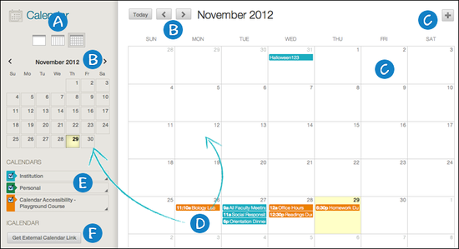
- View events by day, week, or month. Click icons to change view.
- Navigate to another month.
- Create a New Event by clicking on the plus sign or a date. You can then customize the event by providing a title, calendar to display the event, date/time, and description.
- Color-coded display of an event. Need to modify the date? Press and drag to another date OR click the event to manage it (if you have permission).
- Calendar legend. Visible calendars will have a checkmark to the left of the calendar name. To modify the color, click the arrow on the right of the name,
- Link your Blackboard Learn calendar to an external calendar application. Once linked, it will automatically update when any new event is added or items are modified. NOTE: You cannot import external calendar into this calendar.

Creating an Event
When creating an event, you will be asked to provide the following information:
- Title
  - What is visible from the calendar entry?
- Calendar to display the event
  - Select the calendar in which you want the event to appear.
- Start and end time
  - Provide the time for the event.
- Repeat
  - Modify the repeat settings by select how often, the days, and when it will end.
- Event description
  - Provide details about the event.
  - When the event is opened, this will be displayed to the user.

Create an Event
Recurring Events

Customize Calendar
The Calendar functionality plays a key role in keeping users apprised of dates across all courses and organizations. The calendar format also appears in other areas of the course such as Assignments and when using the Date Picker. Users now have these options:
- Choice of Gregorian, Hijri, or both combined format
- Individual choice over "first" day of the week
- Advanced filtering choices
In this example, the calendar is set in combined format (the reverse primary and secondary is an option) along with Monday as the first day of the week.
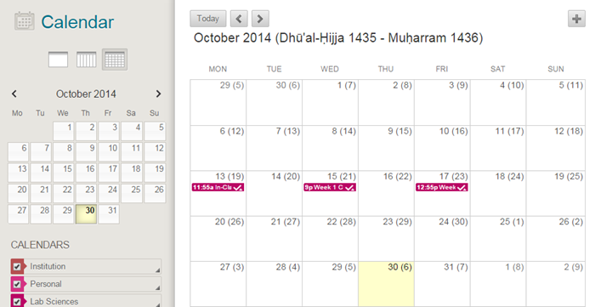

Here are a few more examples.
Assignment Due in Hijri with US English Language Pack
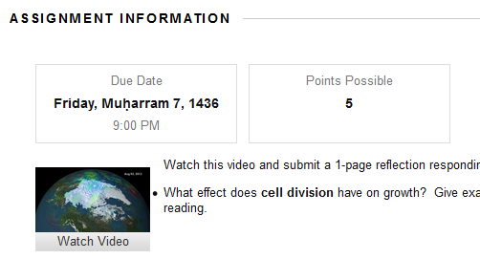
Date Picker in Gregorian Hijri conversion with US English Language Pack
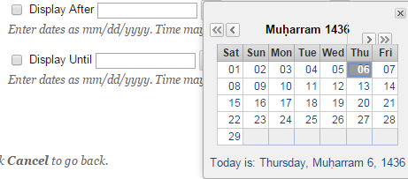
Hijri calendar displayed in Day Mode in Arabic Language Pack
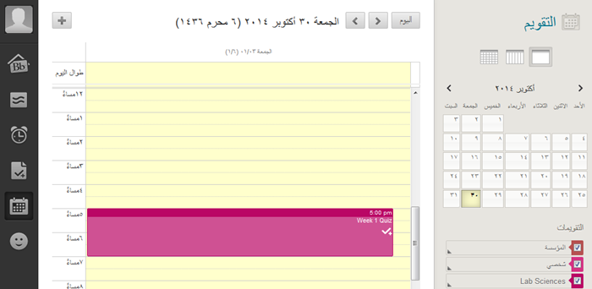
Gregorian calendar with Hijri conversion in Week Mode for US English Language Pack
- 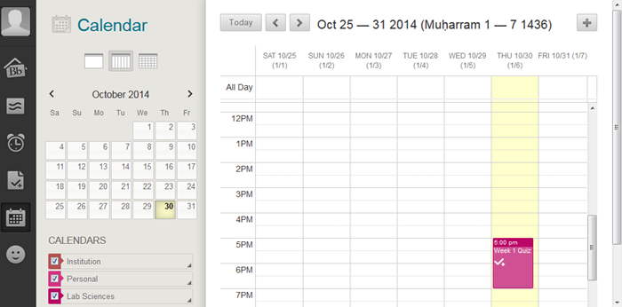

Step to Change Individual Settings
- My Blackboard
- Settings
- Change Personal Settings
- Options
  - User Language Pack
  - Calendar
  - First Day of Week

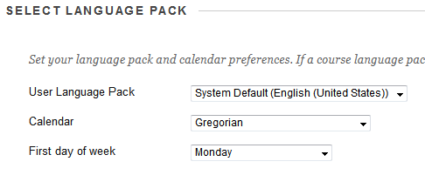

Filtering Calendars
Often users are enrolled in many courses and organizations in one term or have multiple terms visible at one time. When this happens, the calendar “course list” can become quite lengthy with courses that are not actively needed. There is a connection between the “show/hide” capability in the My Courses and My Organizations modules with the calendar course list filter.
To use this feature, follow these steps.
- In the My Courses module click on the Icon in the upper right corner (Manage My Courses Module Setting)
- Remove the check marks from the courses that you wish to hide
- Submit

TRY IT
For this activity, use your Practice Course.
Add the following events to the calendar
- Add one event to this month’s calendar. Include an Event Description.
- Add one event to next month’s calendar.
- View the calendar by month and year.
- Click a calendar event and edit it.
- Drag a calendar event to a new date.

CONTACTS
The Contact Tool allows instructors to create profiles of the instructors, teaching assistants, and guest lectures involved with the course. The benefit of using this tool is it provides a single location for contact information details, which can include: office hours, photo, and other personal data.
This tool can be accessed in a variety of ways:
- From Tools in the Course Menu.
- From Class Tools under Class Management.
- From a Tool Link in the Course Menu (this will need to be created).
Here’s an example of a Contact. Can you identify at least three things that make this Contact page successful?
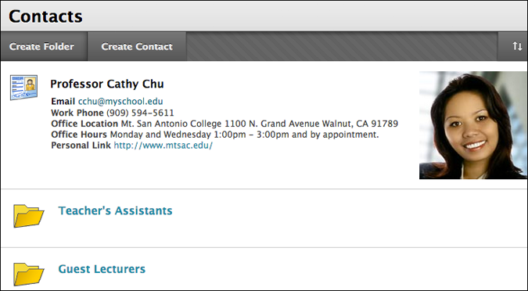

Create a Contact

TRY IT
For this activity, use your Practice Course.
Use the contacts tool
- Create a contact for yourself.
- In the Notes section, include some personal information.
- Create a folder for guest lecturers.

TASKS
Tasks are designed to keep students on track by identifying what needs to be completed for the entire term or a project. When creating a task, the instructor will be asked to provide:
- Task Name: visible to students in the task list.
- Description: details provide will only be visible to users who open the task.
- Due Date: when is this task due?
- Priority: what is the priority for the task
  - low - no icon
  - normal – icon
  - high - icon .
Once a task is visible, students can then select tasks and mark their progress:
- Not started
- In progress
- Complete
At any time, an instructor can visit the task list and see where what progress all the students have made.

Create and Manage Tasks
Create, Edit, and Delete Tasks

Task View - Students
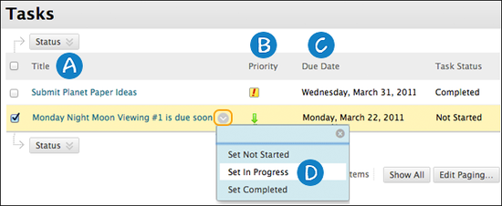
- Task name. Click to open the task and see the description.
- Priority. The assigned level of priority for the task.
- Due date. The date the task is due.
- Task progress. Students can individually set their progress status.

Task View - Instructor
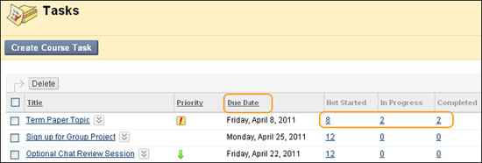
- Create Course Task. Click to create a new task.
- Options Menu. Use to edit or delete.
- Due date. The date the task is due.
- Task progress. Not Started is the default setting, however, once students change their progress, the numbers will change. When the number is clicked: you will view the task, including a list of all the students and their status.
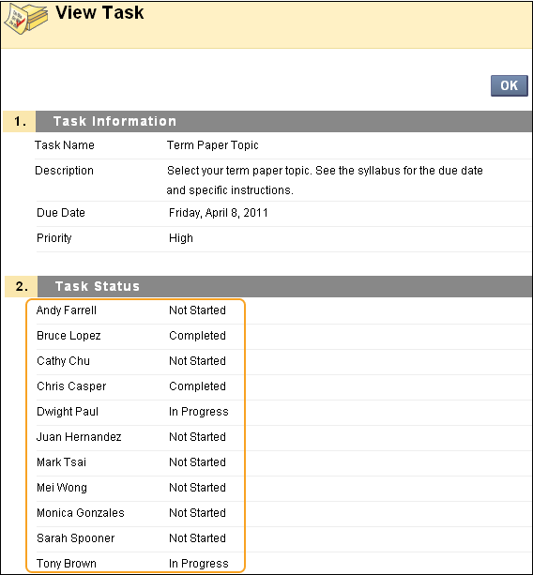

TRY IT
For this activity, use your Practice Course.
Use the tasks tool
- Add a task and assign it a Priority of Normal.
- Check student progress for the Submit Planet Paper Ideas task. Each student is listed twice because two attempts are allowed for this assignment.

SPOTLIGHT ON COMMUNICATION
We have explored some of the course tools Blackboard Learn offers for course information and communication. These tools are either asynchronous or synchronous.
Take a few moments to consider how you can use these tools in your course.
Which course information tools will you use?
- Will you post regular, timely announcements to keep your students updated?
- Will you use an existing syllabus or create one with the syllabus builder?
- Will you add all due dates to the calendar? Have you considered making the calendar the course timeline? Alternatively, will you use the notification modules to inform students of important dates and deadlines?
- Will you add tasks for your students to complete? Will you require students to report their progress?
- Will you add some personal information to your course Contacts page?
Which course communication tools will you use?
- Will you use the Blackboard Learn email tool?
- Or are the course messages tool and its additional privacy a better fit for your course?

Schmieder, Eric J. “Communication: The tool to interact with and control your online classroom environment.” International Journal of Instructional Technology and Distance Learning 5.3. (March 2008). Web. 29 Jul. 2009.

